


Data Compliance Test (DCT)
Test Cases for
Encounter Record

<HCP Name>

Table of Contents
1 Testing Instructions to HCPs 3
1.1 Self-Service Testing Phase 3
1.2 Final Testing Phase 3
1.3 Preparation of DCT Test Report 4
2 Test Case Details 5
2.1 ENCTR-001 [Outpatient] 5
2.2 ENCTR-002 [Outpatient] 9
2.3 ENCTR-003 [Inpatient] 12
2.4 ENCTR-004 [Inpatient] 15
2.5 ENCTR-005 [Inpatient] 18
3 Appendix – Sample Messages 20
4 Appendix – Testing HCP and HCRs Information 22
5 Appendix – Sample Results in eHR Viewer (EVE) 23
6 Appendix – Actual Data Values (Sample) 24

Testing Instructions to HCPs

  - Self-Service Testing Phase

- After development of the data upload programmes, you can use the Self-Service test accounts and test HCRs provided by eHealth for connection to the eHealth testing environment and proceed with the self-service testing.
- You can proceed with the Self-service test at your own pace by following this Self-Service Testing Guide and using the test cases provided in section 2.
- You can verify the correctness and completeness of the data upload by:
  - checking the interface files / messages generated in your system against the sample expected results of interface files /messages for all test cases as provided;
  - checking the results on eHR Viewer (EVE) by logging into the testing eHealth with the provided test account; and
  - checking the upload status through Process Summary and Exception Report in eHR Inbox by logging into the testing eHealth.
- For data fields requiring eHR Codex values, you can refer the Code Sets provided with the Self-Service Kit.
- For details of technical requirements of the data interface files, please refer to the ‘Developer Quick Guide for Encounter Data Upload to eHealth.docx’.
- You are required to perform the first batch of data upload by Data Materialization (DM) mode. DM mode is denoted in the interface by a fixed value BL-M in HL7 OBX.4.
- You should use Incremental Load (INC) mode for the second batch of data upload to update the previously uploaded records. INC mode is denoted in the interface by a fixed value BL in HL7 OBX.4.
- Since the DM mode would replace the corresponding records previously uploaded to eHealth, you may repeat your testing unlimited number of times by uploading the first batch by DM mode.
- It should be noted that the data field “Record Key” should be unique in the whole encounter process. For example, same record key should be used in the appointment booking and attendance marking in an outpatient visit. Meanwhile, same record key should be used in the appointment, attendance and discharge stages within an inpatient encounter.
- When all required test cases can be completed smoothly and correctly in this phase, you can proceed to the Final Testing Phase and submit production environment setup form to eHR DCT Support for preparation.

  - Final Testing Phase
- You can start the Final Testing Phase once all test cases in the Self-Service Testing phase are passed.
- You should start Final Test by executing the test cases provided in section 2 with Final Testing HCRs provided by eHR DCT Support.
- You can verify the correctness and completeness of testing results by checking results in eHR Viewer (EVE) and the upload status through Process Summary and Exception Report in eHR Inbox.
- For Encounter DCT test cases, there are TWO batches of data files / transactions to be uploaded to the testing eHealth. The required records must be correctly uploaded from these 2 consecutive batches respectively.
- The Final Test will be considered PASSED if all the following criteria are met:
  - The TWO batches of test data files are uploaded consecutively in the correct sequence. The second batch of data files/transactions must be submitted after completion of processing of the first batch by eHealth.
  - No additional data files / transactions are uploaded in between or after the uploads of the above two batches of data files / transactions to amend any records.
  - No exception records are reported from the uploads.
  - No manual interventions have been made to the data files / transactions.
- If the Final Test failed, you can re-attempt the Self-Service Test and Final Test until a successful run can be completed.

  - Preparation of DCT Test Report
- Once you have successfully passed the Final Test based on the above criteria, you should complete this document by attaching the below items to this document at the appropriate space provided:
  - Actual data files uploaded
  - Screen-shot of each test case
- You are required to submit this completed ‘DCT Test Cases’ document to eHR DCT Support for further processing. eHR DCT Support will provide feedback within 10 working days.

Test Case Details

1 | Test Case ID | - ENCTR-001 [Outpatient]
 | Function Description | HCP has received the sharing consents from testing HCRs, then perform first data upload of HCRs’ clinical records to eHealth by DM Mode.
 | Subsequent case of | N/A
 | Testing Assumption | - HCR1-HCR6 have already given sharing to sharing consent to your outpatient clinic.  - The EMR system (EMRS) will upload Batch 1 data files to eHealth with all appointment and attendance records of <HCR1> - <HCR6> created by DM mode.
 | Test Actions | HCP creates below encounter records in EMR system:
 | Test Actions | 1a | Mark attendance of a booked appointment in the EMR system for <HCR1>  e.g.  Visit date time = ‘1-Sep-2023 10:30'  Visit clinic identifier = (Source system provided)  Visit clinic long name = (Source system provided)  Visit clinic local name = (Source system provided)  Visit attendance indicator = ‘A’  Encounter type = ‘O’  Visit number = (Source system provided)  Transaction Profile Type = ADM-OP/ ADM-OP-EP  == Actual data values (Refer to “Appendix - Actual Data Values (Sample)” for details)
 | Test Actions | 1b | Create a general future appointment in the EMR system for <HCR2>  e.g.  Visit date time = ‘20-Oct-2023 09:10'  Visit clinic identifier = (Source system provided)  Visit clinic long name = (Source system provided)  Visit clinic local name = (Source system provided)  Visit attendance indicator = [blank]  Encounter type = ‘O’  Appointment number = (Source system provided)  Transaction Profile Type = APP-OP/ APP-OP-EP  == Actual data values (Refer to “Appendix - Actual Data Values (Sample)” for details)
 | Test Actions | 1c | Create a general future appointment in the EMR system for <HCR3>  e.g.  Visit date time = ‘20-Oct-2023 09:20’  Visit clinic identifier = (Source system provided)  Visit clinic long name = (Source system provided)  Visit clinic local name = (Source system provided)  Visit attendance indicator = [blank]  Encounter type = ‘O’  Appointment number = (Source system provided)  Transaction Profile Type = APP-OP/ APP-OP-EP  == Actual data values (Refer to “Appendix - Actual Data Values (Sample)” for details)
 | Test Actions | 1d | Create a general future appointment in the EMR system for <HCR4>  e.g.  Visit date time = ‘20-Oct-2023 09:30’  Visit clinic identifier = (Source system provided)  Visit clinic long name = (Source system provided)  Visit clinic local name = (Source system provided)  Visit attendance indicator = [blank]  Encounter type = ‘O’  Appointment number = (Source system provided)  Transaction Profile Type = APP-OP/ APP-OP-EP  == Actual data values (Refer to “Appendix - Actual Data Values (Sample)” for details)
 | Test Actions | 1e | Create a specialist future appointment in the EMR system for <HCR5> with <Specialty 1>  e.g.  Visit specialty = 'FM'  Visit specialty remark = ‘FM remark’  Visit date time = ‘20-Oct-2023 10:00'  Visit clinic identifier = (Source system provided)  Visit clinic long name = (Source system provided)  Visit clinic local name = (Source system provided)  Visit attendance indicator = [blank]  Encounter type = ‘O’  Appointment number = (Source system provided)  Transaction Profile Type = APP-OP/ APP-OP-EP  * HCP can provide any specialty applicable to its clinic  == Actual data values (Refer to “Appendix - Actual Data Values (Sample)” for details)
 | Test Actions | 1f | Created a specialist future appointment in the EMR system for <HCR6> with <Specialty 2>  e.g.  Visit specialty = 'ENT'  Visit specialty remark = ‘ENT remark’  Visit date time = 20-Oct-2023 10:15'  Visit clinic identifier = (Source system provided)  Visit clinic long name = (Source system provided)  Visit clinic local name = (Source system provided)  Visit attendance indicator = [blank]  Encounter type = ‘O’  Appointment number = (Source system provided)  Transaction Profile Type = APP-OP/ APP-OP-EP  * HCP can provide any specialty applicable to its clinic  == Actual data values (Refer to “Appendix - Actual Data Values (Sample)” for details)
 | Expected EMR System Behavior | - HCP’s EMR system will upload Batch 1 data files with all appointment and attendance records of created in 1a-1f by DM mode.  - Batch 1 data files should include below files: <samples>  - Participant List (PL)  - Data File (DF)  - HL7 message with signature  - Zip File (embedded PL, DF and HL7 message files)  - Control File (contains the filenames of PL, DF and HL7 message)  - EMR system uploads Batch 1 data files (‘Zip File’ and ‘Zip Control File') to eHealth.  - HCP verifies the data upload status by reviewing the 'Process Summary Report' and 'Exception Report' in eHR Inbox.  - HCP verifies the completeness and correctness of data uploaded in eHR Viewer.
 | Results Verification | - HCP verifies if the uploaded records can be properly viewed in eHR Viewer (EVE) and reviews if the data batches uploaded can be processed successfully or rejected through ‘Process Summary’ and ‘Exception Report’ in eHR Inbox.
 | Actual Result  (Screenshot / Attachment) | Data Files Uploaded:  <Attached the Zip file and Control file; password to unzip the file>
 | Actual Result  (Screenshot / Attachment) | Attachment/Screenshot:  <Attached the screen shots of records uploaded in eHR Viewers>
 | Remark | <State your reasons/ justification for exemption with case number>
 | Testing Date | <Provided by HCP>
 | Verified By | <Provided by HCP>

2 | Test Case ID | - ENCTR-002 [Outpatient]
 | Function Description | There are subsequent changes in HCRs’ clinical records in Batch 1 data upload. HCP uploads increment changes to eHealth by INC Mode.
 | Subsequent case of | ENCTR-001
 | Testing Assumption | - HCP has already verified Batch 1 data are completed successfully.
 | Test Actions | HCP updates below encounter records in EMR system (EMRS):
 | Test Actions | 2a | <HCR2> requested to cancel the future appointment by updating the attendance status of the existing record in the EMR system.  e,g.  Visit date time = ‘20-Oct-2023 09:10'  Visit clinic identifier = (Source system provided)  Visit clinic long name = (Source system provided)  Visit clinic local name = (Source system provided)  Visit attendance indicator = ‘C’  Encounter type = ‘O’  Appointment number = (Source system provided)  Transaction Profile Type = APP-OP/ APP-OP-EP  Notes:  If ‘Visit attendance indicator’ is not applicable in your EMR system, HCP may use ‘Delete’ transaction to remove the unexpected appointment record.  == Actual data values (Refer to “Appendix - Actual Data Values (Sample)” for details)
 | Test Actions | 2b | <HCR3> marked attendance by updating the attendance status of existing appointment in the EMR system.  e.g.  Visit date time = ‘20-Oct-2023 09:20’  Visit clinic identifier = (Source system provided)  Visit clinic long name = (Source system provided)  Visit clinic local name = (Source system provided)  Visit attendance indicator = ‘A’  Encounter type = ‘O’  Appointment number = (Source system provided)  Visit number = (Source system provided)  Transaction Profile Type = ADM-OP/ ADM-OP-EP  Notes:  If ‘Visit attendance indicator’ is not applicable in your EMR system, HCP may request for exemption to skip this test case.  == Actual data values (Refer to “Appendix - Actual Data Values (Sample)” for details)
 | Test Actions | 2c | <HCR5> requested to change the future appointment date  e.g.  Visit specialty = 'FM'  Visit specialty remark = ‘FM remark’  Visit date time = ‘22-Oct-2023 09:20’  Visit clinic identifier = (Source system provided)  Visit clinic long name = (Source system provided)  Visit clinic local name = (Source system provided)  Visit attendance indicator = [blank]  Encounter type = ‘O’  Appointment number = (Source system provided)  Transaction Profile Type = APP-OP/ APP-OP-EP  == Actual data values (Refer to “Appendix - Actual Data Values (Sample)” for details)
 | Test Actions | 2d | <HCR6> requested to change the specialty  e.g.  Visit specialty = 'FM’  Visit specialty remark = ‘Change from ENT to FM remark’  Visit date time = 20-Oct-2023 10:15'  Visit clinic identifier = (Source system provided)  Visit clinic long name = (Source system provided)  Visit clinic local name = (Source system provided)  Visit attendance indicator = [blank]  Encounter type = ‘O’  Appointment number = (Source system provided)  Transaction Profile Type = APP-OP/ APP-OP-EP  == Actual data values (Refer to “Appendix - Actual Data Values (Sample)” for details)
 | Test Actions | 2e | The incorrect appointment of <HCR4> was uploaded in Batch 1, user has deleted the record in EMR system.  Transaction Profile Type = APP-OP/ APP-OP-EP  == Actual data values (Refer to “Appendix - Actual Data Values (Sample)” for details)
 | Expected EMR System Behavior | - HCP’s EMR system generated Batch 2 data file with items 2a-2e transactions to eHealth.  - Batch 2 data files should include below files: <samples>  - Participant List (PL)  - Data File (DF)  - HL7 message with signature  - Zip File (embedded PL, DF and HL7 message files)  - Control File (contains the filenames of PL, DF and HL7 message)  - EMR system uploads Batch 2 data files (‘Zip File’ and ‘Zip Control File') to eHealth.  - HCP verifies the data upload status by reviewing the 'Process Summary Report' and 'Exception Report' in eHR Inbox.  - HCP verifies the completeness and correctness of data uploaded in eHR Viewer.
 | Results Verification | - HCP verifies if the uploaded records can be properly viewed in eHR Viewer (EVE) and reviews if the data batches uploaded can be processed successfully or rejected through ‘Process Summary’ and ‘Exception Report’ in eHR Inbox.
 | Actual Result  (Screenshot / Attachment) | Data Files Uploaded:  <Attached the Zip file and Control file; password to unzip the file>
 | Actual Result  (Screenshot / Attachment) | Attachment/Screenshot:  <Attached the screen shots of records uploaded in eHR Viewers>
 | Remark | <State your reasons/ justification for exemption with case number>
 | Testing Date | <Provided by HCP>
 | Verified By | <Provided by HCP>

3 | Test Case ID | - ENCTR-003 [Inpatient]
 | Function Description | HCP has received the sharing consents from testing HCRs, then perform first data upload of HCRs’ clinical records to eHealth by DM Mode.
 | Subsequent case of | N/A
 | Testing Assumption | - HCR7-HCR10 have already given sharing to sharing consent to your healthcare institution.  - The EMR system will upload Batch 3 data files to eHealth with all appointment and attendance records of <HCR7> - <HCR10> created by DM mode.
 | Test Actions | HCP creates below encounter records in EMR system (EMRS):
 | Test Actions | 3a | Create an Inpatient appointment record in the EMR system for <HCR7>  e.g.  Episode start date time = ‘1-Sep-2022 10:30'  Episode end date time = [blank]  Appointment Number = 1111555  Discharge Type = [blank]  Encounter type = ‘I’  Transaction Profile Type = APP-IP  == Actual data values (Refer to “Appendix - Actual Data Values (Sample)” for details)
 | Test Actions | 3b | Create an Inpatient admission record in the EMR system for <HCR8>  e.g.  Episode start date time = ‘1-Sep-2023 10:30'  Episode end date time = [blank]  Episode Number = 222222  Discharge Type = [blank]  Encounter type = ‘I’  Transaction Profile Type = ADM-IP  == Actual data values (Refer to “Appendix - Actual Data Values (Sample)” for details)
 | Test Actions | 3c | Create an Inpatient discharge record in the EMR system for <HCR9>  e.g.  Episode start date time = ‘1-Sep-2024 10:30'  Episode end date time = ‘10-Sep-2024 15:30'  Episode Number = 222222  Discharge Type = ‘HOME’  Encounter type = ‘I’  Transaction Profile Type = DIS-IP  == Actual data values (Refer to “Appendix - Actual Data Values (Sample)” for details)
 | Test Actions | 3d | Create an Inpatient discharge record in the EMR system for <HCR10>  e.g.  Episode start date time = ‘1-Oct-2024 10:30'  Episode end date time = ‘10-Oct-2024 15:30'  Episode Number = 333333  Discharge Type = ‘HOME’  Encounter type = ‘I’  Transaction Profile Type = DIS-IP  == Actual data values (Refer to “Appendix - Actual Data Values (Sample)” for details)
 | Expected EMR System Behavior | - HCP’s EMR system will upload Batch 3 data files with all inpatient records of created in 3a-3d by DM mode.  - Batch 3 data files should include below files: <samples>  - Participant List (PL)  - Data File (DF)  - HL7 message with signature  - Zip File (embedded PL, DF and HL7 message files)  - Control File (contains the filenames of PL, DF and HL7 message)  - EMR system uploads Batch 3 data files (‘Zip File’ and ‘Zip Control File') to eHealth.  - HCP verifies the data upload status by reviewing the 'Process Summary Report' and 'Exception Report' in eHR Inbox.  - HCP verifies the completeness and correctness of data uploaded in eHR Viewer.
 | Results Verification | - HCP verifies if the uploaded records can be properly viewed in eHR Viewer (EVE) and reviews if the data batches uploaded can be processed successfully or rejected through ‘Process Summary’ and ‘Exception Report’ in eHR Inbox.
 | Actual Result  (Screenshot / Attachment) | Data Files Uploaded:  <Attached the Zip file and Control file; password to unzip the file>
 | Actual Result  (Screenshot / Attachment) | Attachment/Screenshot:  <Attached the screen shots of records uploaded in eHR Viewers>
 | Remark | <State your reasons/ justification for exemption with case number>
 | Testing Date | <Provided by HCP>
 | Verified By | <Provided by HCP>

4 | Test Case ID | - ENCTR-004 [Inpatient]
 | Function Description | There are subsequent changes in HCRs’ clinical records in Batch 3 data upload. HCP uploads increment changes to eHealth by INC Mode.
 | Subsequent case of | ENCTR-003
 | Testing Assumption | - HCP has already verified Batch 3 data are completed successfully.
 | Test Actions | HCP creates below encounter records in EMR system (EMRS):
 | Test Actions | 4a | Mark admission of an Inpatient appointment record in the EMR system for <HCR7>  e.g.  Episode start date time = ‘1-Sep-2022 10:30'  Episode end date time = [blank]  Appointment Number = 1111555  Episode Number = 222555  Discharge Type = [blank]  Encounter type = ‘I’  Transaction Profile Type = ADM-IP  == Actual data values (Refer to “Appendix - Actual Data Values (Sample)” for details)
 | Test Actions | 4b | Update an Inpatient admission record to discharge in the EMR system for <HCR8>  e.g.  Episode start date time = ‘1-Sep-2023 10:30'  Episode end date time = ‘10-Sep-2023 15:30'  Episode Number = 222222  Discharge Type = ‘HOME’  Encounter type = ‘I’  Transaction Profile Type = DIS-IP  == Actual data values (Refer to “Appendix - Actual Data Values (Sample)” for details)
 | Test Actions | 4c | Update an Inpatient discharge record in the EMR system for <HCR9>  e.g.  Episode start date time = ‘1-Sep-2024 10:30'  Episode end date time = ‘12-Sep-2024 15:30'  Episode Number = 222222  Discharge Type = ‘DEATH’  Encounter type = ‘I’  Transaction Profile Type = DIS-IP  == Actual data values (Refer to “Appendix - Actual Data Values (Sample)” for details)
 | Test Actions | 4d | The incorrect Inpatient record of <HCR10> was uploaded in Batch 3, user has deleted the record in EMR system.  Transaction Profile Type = APP-IP/ ADM-IP/ DIS-IP  == Actual data values (Refer to “Appendix - Actual Data Values (Sample)” for details)
 | Expected EMR System Behavior | - HCP’s EMR system will upload Batch 3 data files with all inpatient records of created in 3a-3d by DM mode.  - Batch 4 data files should include below files: <samples>  - Participant List (PL)  - Data File (DF)  - HL7 message with signature  - Zip File (embedded PL, DF and HL7 message files)  - Control File (contains the filenames of PL, DF and HL7 message)  - EMR system uploads Batch 4 data files (‘Zip File’ and ‘Zip Control File') to eHealth.  - HCP verifies the data upload status by reviewing the 'Process Summary Report' and 'Exception Report' in eHR Inbox.  - HCP verifies the completeness and correctness of data uploaded in eHR Viewer.
 | Results Verification | - HCP verifies if the uploaded records can be properly viewed in eHR Viewer (EVE) and reviews if the data batches uploaded can be processed successfully or rejected through ‘Process Summary’ and ‘Exception Report’ in eHR Inbox.
 | Actual Result  (Screenshot / Attachment) | Data Files Uploaded:  <Attached the Zip file and Control file; password to unzip the file>
 | Actual Result  (Screenshot / Attachment) | Attachment/Screenshot:  <Attached the screen shots of records uploaded in eHR Viewers>
 | Remark | <State your reasons/ justification for exemption with case number>
 | Testing Date | <Provided by HCP>
 | Verified By | <Provided by HCP>

5 | Test Case ID | - ENCTR-005 [Inpatient]
 | Function Description | There are subsequent changes in HCRs’ clinical records in Batch 4 data upload. HCP uploads increment changes to eHealth by INC Mode.
 | Subsequent case of | ENCTR-004
 | Testing Assumption | - HCP has already verified Batch 4 data are completed successfully.
 | Test Actions | HCP creates below encounter records in EMR system (EMRS):
 | Test Actions | 5a | Update an Inpatient admission record to discharge in the EMR System for <HCR7>  e.g.  Episode start date time = ‘1-Sep-2022 10:30'  Episode end date time = ‘10-Sep-2023 15:30'  Appointment Number = 1111555  Episode Number = 222555  Discharge Type = ‘HOME’  Encounter type = ‘I’  Transaction Profile Type = DIS-IP  == Actual data values (Refer to “Appendix - Actual Data Values (Sample)” for details)
 | Expected EMR System Behavior | - HCP’s EMR system will upload Batch 3 data files with all inpatient records of created in 3a-3d by DM mode, and will upload Batch 4 data files with all inpatient records updated in 4a – 4e by INC mode.  - Batch 5 data files should include below files: <samples>  - Participant List (PL)  - Data File (DF)  - HL7 message with signature  - Zip File (embedded PL, DF and HL7 message files)  - Control File (contains the filenames of PL, DF and HL7 message)  - EMR system uploads Batch 5 data files (‘Zip File’ and ‘Zip Control File') to eHealth.  - HCP verifies the data upload status by reviewing the 'Process Summary Report' and 'Exception Report' in eHR Inbox.  - HCP verifies the completeness and correctness of data uploaded in eHR Viewer.
 | Results Verification | - HCP verifies if the uploaded records can be properly viewed in eHR Viewer (EVE) and reviews if the data batches uploaded can be processed successfully or rejected through ‘Process Summary’ and ‘Exception Report’ in eHR Inbox.
 | Actual Result  (Screenshot / Attachment) | Data Files Uploaded:  <Attached the Zip file and Control file; password to unzip the file>
 | Actual Result  (Screenshot / Attachment) | Attachment/Screenshot:  <Attached the screen shots of records uploaded in eHR Viewers>
 | Remark | <State your reasons/ justification for exemption with case number>
 | Testing Date | <Provided by HCP>
 | Verified By | <Provided by HCP>

Appendix – Sample Messages

Test Case ID | File Type | Bulk Load Format | SOAP Format (by LAAM)
ENCTR-001  (1a-1f) | Participant List (PL)
ENCTR-001  (1a-1f) | Data File (DF)
ENCTR-001  (1a-1f) | HL7 Message
ENCTR-001  (1a-1f) | Zip File | (Password: Abcd1234)
ENCTR-001  (1a-1f) | Control File
NCTR-002  (2a-2f) | Participant List (PL)
NCTR-002  (2a-2f) | Data File (DF)
NCTR-002  (2a-2f) | HL7 Message
NCTR-002  (2a-2f) | Zip File | (Password: Abcd1234)
NCTR-002  (2a-2f) | Control File
ENCTR-003  (3a-3d) | Participant List (PL)
ENCTR-003  (3a-3d) | Data File (DF)
ENCTR-003  (3a-3d) | HL7 Message
ENCTR-003  (3a-3d) | Zip File | (Password: Abcd1234)
ENCTR-003  (3a-3d) | Control File
ENCTR-004  (4a-4d) | Participant List (PL)
ENCTR-004  (4a-4d) | Data File (DF)
ENCTR-004  (4a-4d) | HL7 Message
ENCTR-004  (4a-4d) | Zip File | (Password: Abcd1234)
ENCTR-004  (4a-4d) | Control File
ENCTR-005  (5a) | Participant List (PL)
ENCTR-005  (5a) | Data File (DF)
ENCTR-005  (5a) | HL7 Message
ENCTR-005  (5a) | Zip File | (Password: Abcd1234)
ENCTR-005  (5a) | Control File

Appendix – Testing HCP and HCRs Information

Sample Message
Self-Service Testing | <Attach the testing HCRs excel file used>
Final Testing | <Attach the testing HCRs excel file used>

  - eHR DCT Support will provide other sets of testing HCRs for HCP to perform Self-Service testing and Final testing respectively.

Appendix – Sample Results in eHR Viewer (EVE)

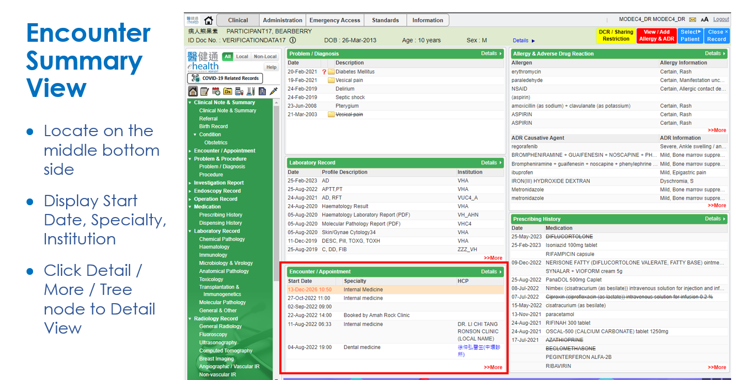

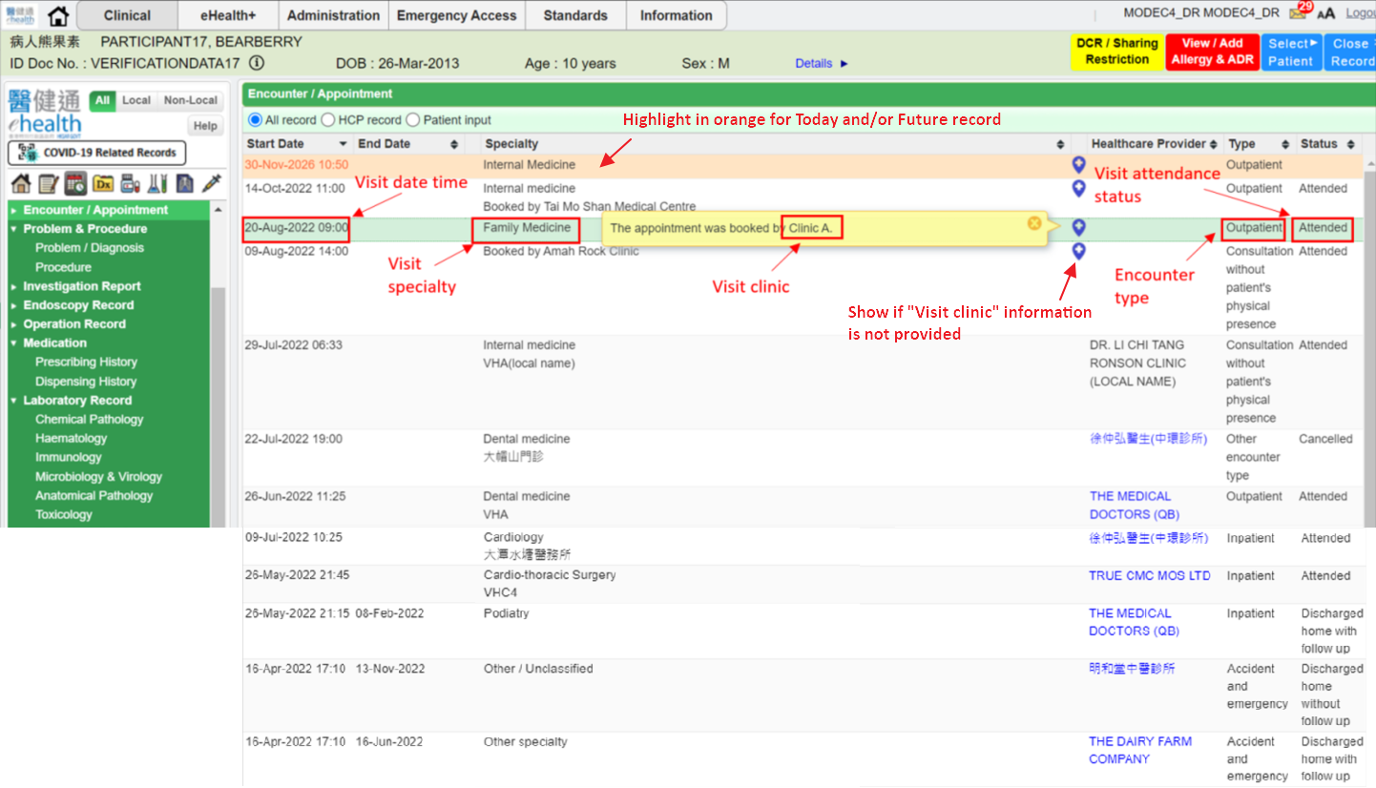

Appendix – Actual Data Values (Sample)

If the actual values entered are various from the test case, please provide actual values as below.
If the value is not inputted, please use [BLANK] to indicate that empty value is inputted intentionally.

